# Accessing info and documents saved on my state computer, such as the S: Drive or H: Drive, etc.

1: Open Browser and browse to **mfa.citrix.mt.gov.**



2. Log In using your **CP#, Network Password and RSA Token**. If you are prompted to save your password, please select Never.

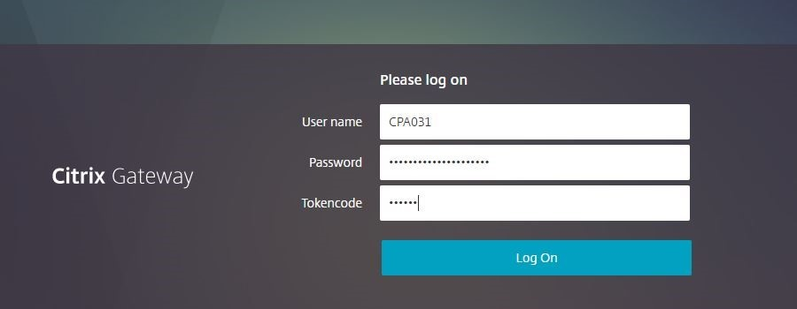

3. If this is your first time using Citrix, you may be prompted to **Detect Receiver**.  Click the link when prompted.

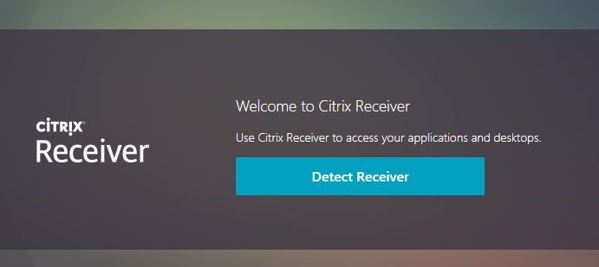

4. You will be prompted to open the Citrix launcher – Select **Open Citrix Workspace Launcher**.

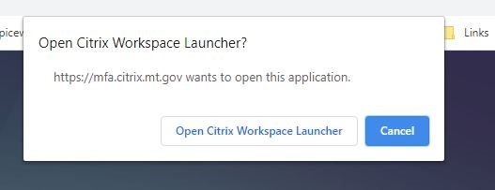

5. Once logged in, choose **Desktops** from the menu at the top of the page.

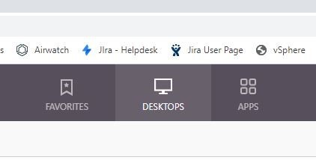

6. Choose the **OPI Desktop 2016** in the next screen, icon like pictured below.

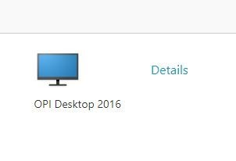

7. The desktop window should appear.  Press OK to enter the Citrix Desktop

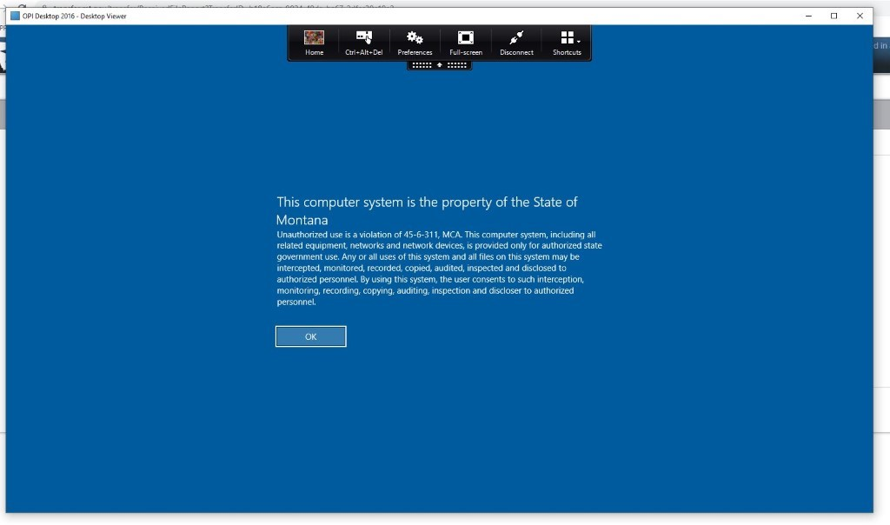

8. **You may see a security warning asking you to either block access or permit use.  Click the Do Not Ask Again box, then choose Permit Use**. When opening files on your remote Citrix desktop, you may see a security prompt similar to the one pictured that asks about the type of access you want to allow. Select the **Do Not Ask** again box and select **Read/Write access.**

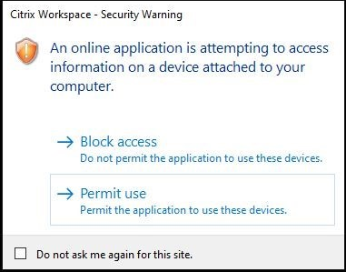

9. When close the Citrix Desktop, make sure to select Sign Out rather than Disconnect, which can leave your profile open and vulnerable to corruption.